Dear Friend of Servite,
Servite High School is a non-profit, private Catholic High School, serving a diverse population of students from Southern California. We are dedicated to ensuring that our students have the ability to flourish in a spiritual environment encompassing high academic levels and expectations, leadership opportunities, competitive athletic programs, exceptional fine arts and on-going social outreach initiatives.
Once a year Servite High School and our Parent Community Council host an extraordinary event, the Servite Fashion Show, Boutique, and Luncheon. Your support plays a very important role in Servite’s ability to deliver educational excellence to approximately 800 young men. The monies raised will allow Servite to provide an exceptional education for all students while also providing more than $700,000 in financial assistance to approximately 40% of our students.
Our 62nd Annual Fashion Show, Luncheon, and Boutique, Full of Grace, will be held on Sunday, November 8, 2020 at the Anaheim Marriott. The event is attended by more than 800 guests and includes a holiday boutique, silent and live auctions, raffles, luncheon and professionally choreographed Fashion Show featuring Servite students and their moms.
To help us in this effort of helping the men of Servite, we ask you to consider becoming an event sponsor or underwriter. Sponsorship levels include:
Platinum Sponsor $15,000
Gold Sponsor $10,000
Silver Sponsor $5,000
Bronze Sponsor $2,500
Black Sponsor $1,000
White Sponsor $500
Please take a few moments to review the details of each opportunity on the enclosed forms. We recognize there are many deserving organizations that request your charitable support, and it is our hope that you will consider Servite High School a worthy beneficiary. For further information, please contact Steffanie Early, Underwriting & Sponsorship Chair, at fashionshow@servitehs.org or by phone at 714-774-7575 x 1127. Again, we are grateful for your consideration and future support.

Gratefully yours,

Your Name Here
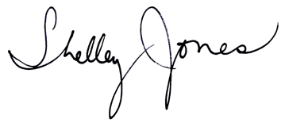
Your Son(s)’ Names) & Year(s)
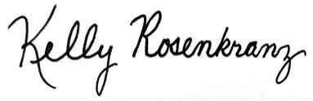
Kelly Rosenkranz Shelley Jones
Mother of Cade ’19, Riley ’22, & Quinn ’24 Mother of Lachlan ’23

Servite Tax ID #95-2023055

